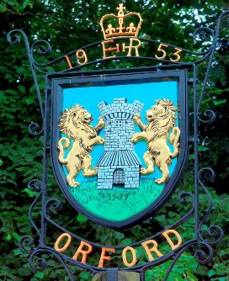
Orford & Gedgrave Parish Council
would like to invite you to our
D-Day 80 Commemoration Event
On Thursday 6th June 2024 at 5.30pm in the Town Hall, where there will be Fish & Chips, with a dessert of steamed pudding and custard. Music from the 1940’s will also be playing. Finishing the evening off at 9pm with the lighting of the beacon.

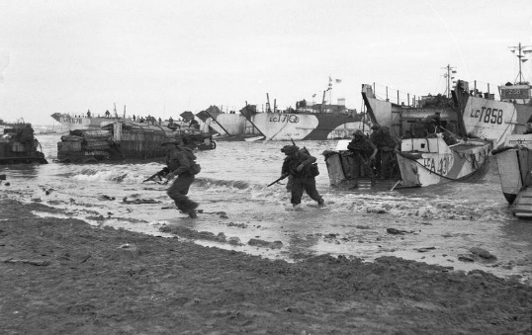
This Photo by Unknown Author is licensed under CC BY-SA
Please contact the office on 01394 459172 or email orfordtownhall@outlook.com
if you think you are able to join us. Thank you.

